Assignment 15

--1. Create the tables Customersand Orderswith the following columns. ( do not declare the corresponding primary and foreign keys

Create table Customers (CustomerId char(5) not null,

CompanyName varchar(40) not null, contactName char(30) null,

Address Varchar(60) null, City char(15) null, Phone char(24) null,

Fax Char(24) null);

Create table Orders (OrderId integer not null, customerId char(5) not null,

Orderdate datetime null, Shippeddate datetime null, Freight money null,

Shipname varchar(40) null, Shipaddress varchar(60) null,

Quantity integer null);

Output:

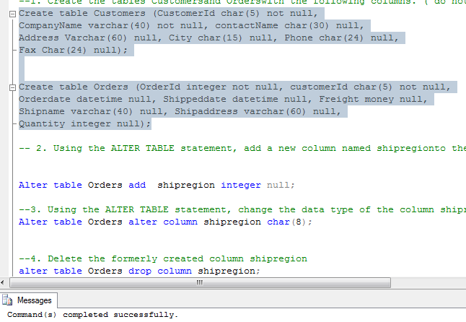

-- 2. Using the ALTER TABLE statement, add a new column named shipregionto the Orderstable. The fields should be nullable and contain integers

Alter table Orders add shipregion integer null;

Output:

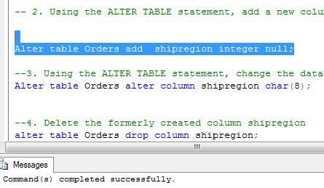

--3. Using the ALTER TABLE statement, change the data type of the column shipregion from INTEGER to CHARACTER with length 8. The fields may contain null values

Alter table Orders alter column shipregion char(8);

output

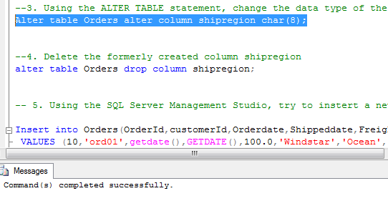

--4. Delete the formerly created column shipregion

alter table Orders drop column shipregion;

Output

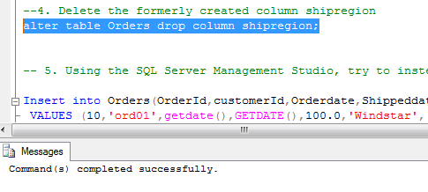

-- 5. Using the SQL Server Management Studio, try to instert a new row into the Orderstable with the following values:( 10, ‘ord01’, getdate(), getdate(), 100.0, ‘Windstar’, ‘Ocean’ ,1)

Insert into Orders(OrderId,customerId,Orderdate,Shippeddate,Freight,Shipname,Shipaddress,Quantity)

VALUES (10,'ord01',getdate(),GETDATE(),100.0,'Windstar','Ocean',1);

Output

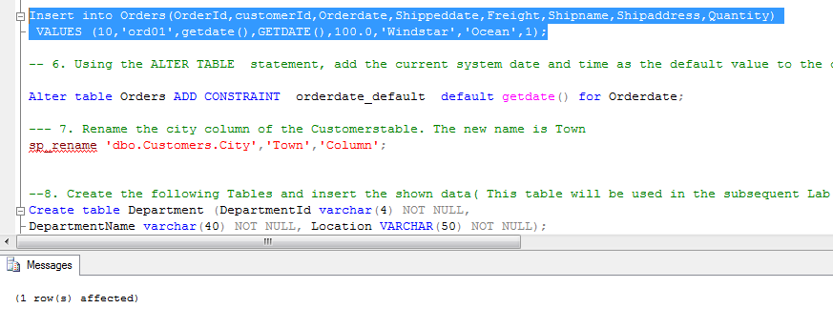

-- 6. Using the ALTER TABLE statement, add the current system date and time as the default value to the orderdatecolumn of the Orderstable

Alter table Orders ADD CONSTRAINT orderdate_default default getdate() for Orderdate;

Output

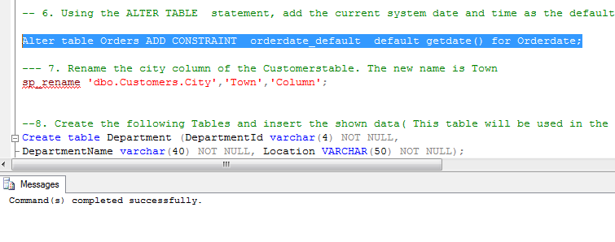

--- 7. Rename the city column of the Customerstable. The new name is Town

sp_rename 'dbo.Customers.City','Town','Column';

output

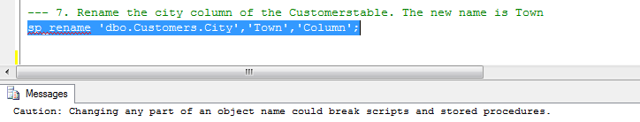

--8. Create the following Tables and insert the shown data( This table will be used in the subsequent Lab sessions

Create table Department (DepartmentId varchar(4) NOT NULL,

DepartmentName varchar(40) NOT NULL, Location VARCHAR(50) NOT NULL);

Insert into Department (DepartmentId, DepartmentName, Location) VALUES ('d1','Residency','Dallas');

Insert into Department (DepartmentId, DepartmentName, Location) VALUES ('d2','Accounts','Seattle');

Insert into Department (DepartmentId, DepartmentName, Location) VALUES ('d3','Managment','Dallas');

CREATE TABLE Employee (EmployeeId integer not null, emp_fname Varchar(20) NOT NULL,

emp_lname varchar(20) NOT NULL, dep_id varchar(4) not null);

Insert into Employee (EmployeeId,emp_fname,emp_lname,dep_id) VALUES (25348,'Matthew','Smith','d3');

Insert into Employee (EmployeeId,emp_fname,emp_lname,dep_id) VALUES (10102,'Ann','Jones','d3');

Insert into Employee (EmployeeId,emp_fname,emp_lname,dep_id) VALUES (18316,'John','Barrimor','d1');

Insert into Employee (EmployeeId,emp_fname,emp_lname,dep_id) VALUES (25348,'James','James','d2');

Create table Project (Project_no varchar(10) NOT NULL, Project_name varchar(50) Not Null,

Budget money );

Insert into Project (Project_no , Project_name,Budget ) VALUES ('p1','Apollo',12000);

Insert into Project (Project_no , Project_name,Budget ) VALUES ('p2','Gemini',95000);

Insert into Project (Project_no , Project_name,Budget ) VALUES ('p3','Mercury',18560);

Create table Works_on (emp_no integer, Project_no varchar(10), Job Varchar(30) NULL, enter_date date);

SELECT * FROM Works_on

INSERT INTO Works_on (emp_no,Project_no,Job,enter_date) VALUES (10102,'p1','Analyst','10-01-1997');

INSERT INTO Works_on (emp_no,Project_no,Job,enter_date) VALUES (10102,'p3','Manager','01-01-1999');

INSERT INTO Works_on (emp_no,Project_no,Job,enter_date) VALUES (25348,'p2','Clerk','02-15-1998');

INSERT INTO Works_on (emp_no,Project_no,Job,enter_date) VALUES (18316,'p2',NULL,'06-01-1998');

INSERT INTO Works_on (emp_no,Project_no,Job,enter_date) VALUES (29346,'p2',NULL,'12-15-1997');

INSERT INTO Works_on (emp_no,Project_no,Job,enter_date) VALUES (2581,'p3','Analyst','10-15-1998');

INSERT INTO Works_on (emp_no,Project_no,Job,enter_date) VALUES (28559,'p1','Manager','04-15-1998');

INSERT INTO Works_on (emp_no,Project_no,Job,enter_date) VALUES (28559,'p2','Clerk','02-01-1992');

INSERT INTO Works_on (emp_no,Project_no,Job,enter_date) VALUES (9031,'p3','Clerk','11-15-1997');

INSERT INTO Works_on (emp_no,Project_no,Job,enter_date) VALUES (29346,'p1','Clerk','01-04-1998');

-- 8. 1 Get all row of the works_ontable

SELECT * FROM Works_on;

Output:

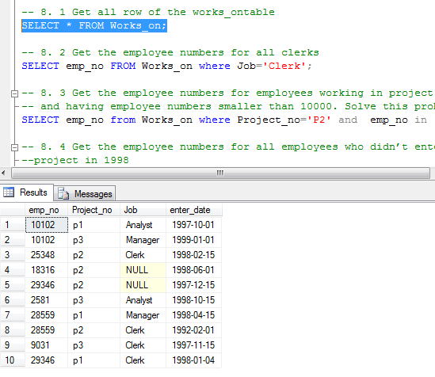

-- 8. 2 Get the employee numbers for all clerks

SELECT emp_no FROM Works_on where Job='Clerk';

Output:

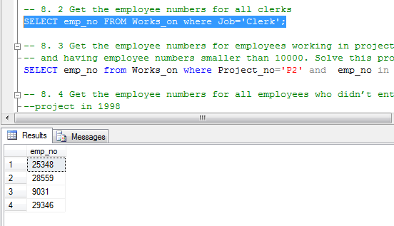

-- 8. 3 Get the employee numbers for employees working in project p2,

-- and having employee numbers smaller than 10000. Solve this problem with two different but equivalent SELECT statements

SELECT emp_no from Works_on where Project_no='P2' and emp_no in (SELECT emp_no from Works_on WHERE emp_no <10000)

Output:

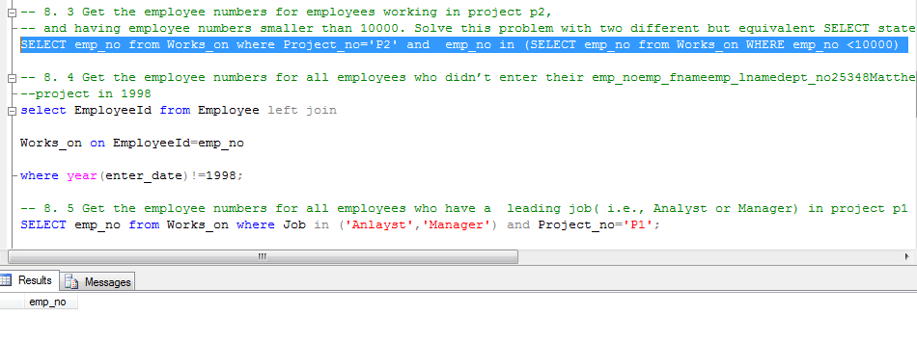

-- 8. 4 Get the employee numbers for all employees who didn’t enter their emp_noemp_fnameemp_lnamedept_no25348MatthewSmithd310102AnnJonesd318316JohnBarrimored129346JamesJamesd2

--project in 1998

select EmployeeId from Employee left join

Works_on on EmployeeId=emp_no

where year(enter_date)!=1998;

output:

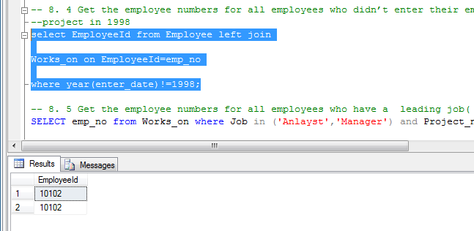

-- 8. 5 Get the employee numbers for all employees who have a leading job( i.e., Analyst or Manager) in project p1

SELECT emp_no from Works_on where Job in ('Anlayst','Manager') and Project_no='P1';

Output:

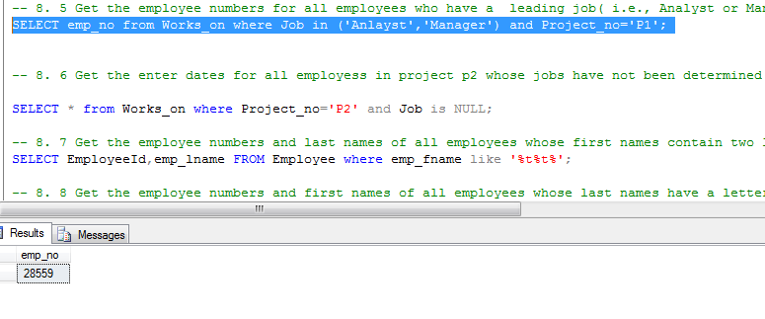

-- 8. 6 Get the enter dates for all employess in project p2 whose jobs have not been determined yet

SELECT * from Works_on where Project_no='P2' and Job is NULL;

Output:

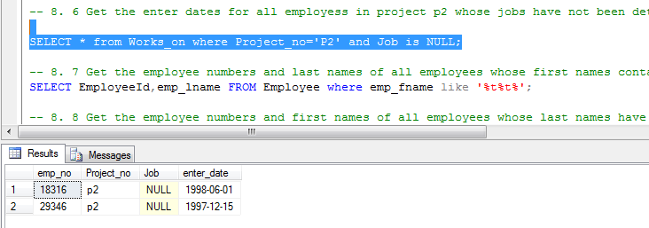

-- 8. 7 Get the employee numbers and last names of all employees whose first names contain two letter t’s

SELECT EmployeeId,emp_lname FROM Employee where emp_fname like '%t%t%';

Output:

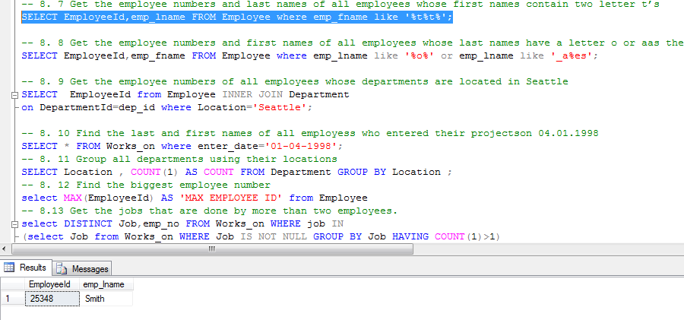

-- 8. 8 Get the employee numbers and first names of all employees whose last names have a letter o or aas the second character and end with the letters es

SELECT EmployeeId,emp_fname FROM Employee where emp_lname like '%o%' or emp_lname like '_a%es';

Output:

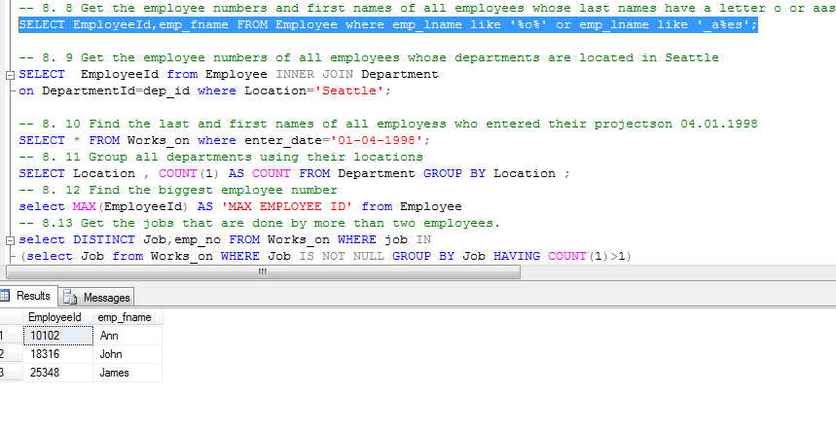

-- 8. 9 Get the employee numbers of all employees whose departments are located in Seattle

SELECT EmployeeId from Employee INNER JOIN Department

on DepartmentId=dep_id where Location='Seattle';

output:

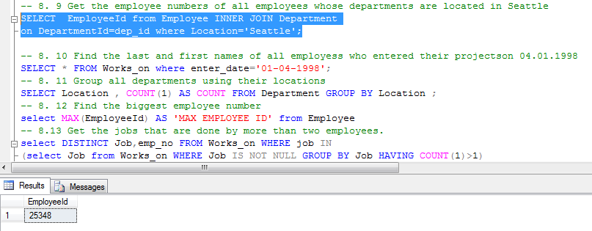

-- 8. 10 Find the last and first names of all employess who entered their projectson 04.01.1998

SELECT * FROM Works_on where enter_date='01-04-1998';

Output:

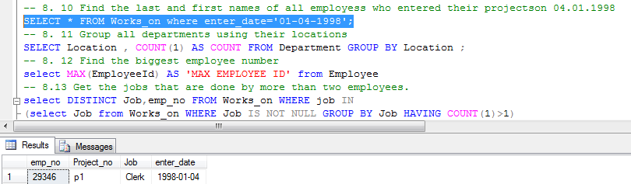

-- 8. 11 Group all departments using their locations

SELECT Location , COUNT(1) AS COUNT FROM Department GROUP BY Location ;

Output:

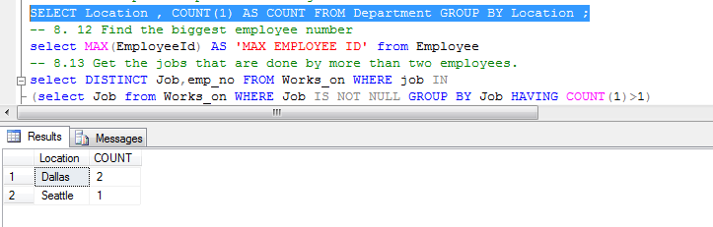

-- 8. 12 Find the biggest employee number

select MAX(EmployeeId) AS 'MAX EMPLOYEE ID' from Employee

Output:

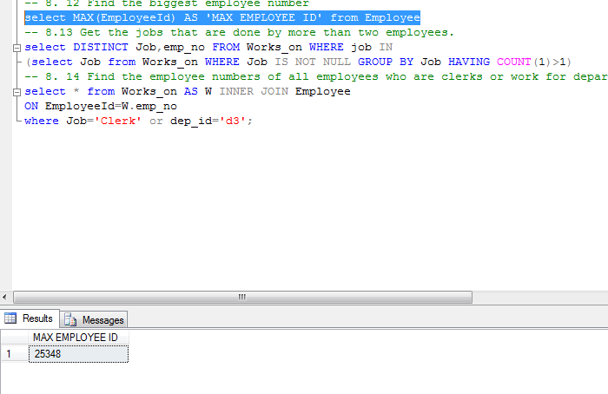

-- 8.13 Get the jobs that are done by more than two employees.

select DISTINCT Job,emp_no FROM Works_on WHERE job IN

(select Job from Works_on WHERE Job IS NOT NULL GROUP BY Job HAVING COUNT(1)>1)

Output:

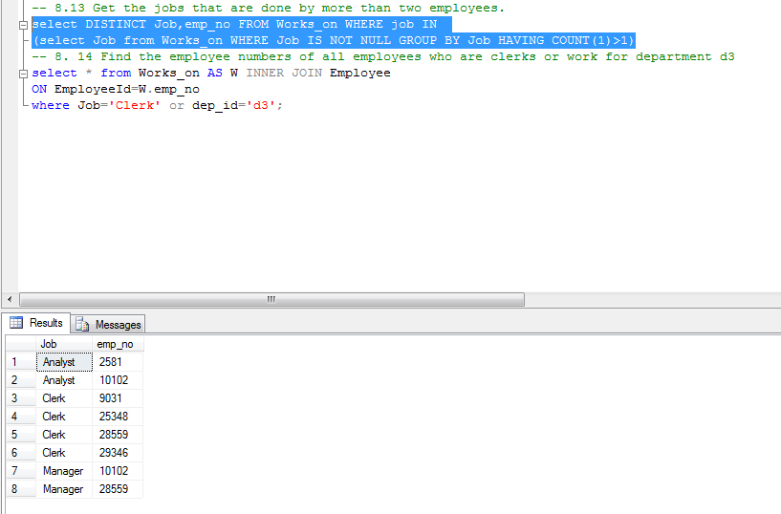

-- 8. 14 Find the employee numbers of all employees who are clerks or work for department d3

select * from Works_on AS W INNER JOIN Employee

ON EmployeeId=W.emp_no

where Job='Clerk' or dep_id='d3';

Output:

